Wick Court’s 20th Anniversary

Sir Michael and Lady Morpurgo founded Farms for City Children over forty years ago. The aim was to offer urban children from all over the country a unique opportunity to live and work together, for a week at a time, on a real farm in the heart of the countryside. It is an intense ‘learning through doing’ experience for children who may not know where their food comes from and have limited chance to explore life outside their city. The charity runs three farms, one of which is local to you - Wick Court – in Gloucestershire on the banks of the River Severn. Each year more than 1000 children and 400 teachers enjoy a week of “Muck and Magic” at the farm.

Wick Court opened its doors to children on 21st June 1998

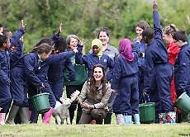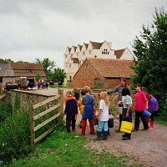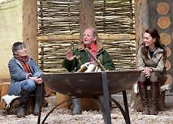

We’d love you to get involved and join the family!

We hope you will be able to help us sustain the valuable work of the farm for the future.
We hold events throughout the year, so everyone can enjoy what Wick Court has to offer and see their generosity and the charity in action.

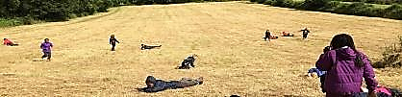

Please join us to make the next twenty years even more valuable for children and our local community

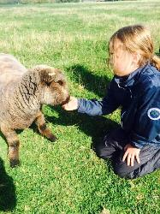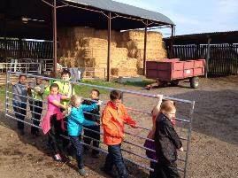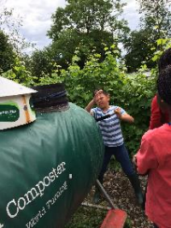

How can you help?

We need a car park!
Not the most exciting of projects we admit but utterly essential.
We want to be able to involve more local schools including those schools that work with children with physical disabilities and special educational needs.

Of course for all children and adults, we know the positive mental health and well-being benefits that come from spending time on the farm and connecting with the countryside. We would love the local community to enjoy our trail walks; open a produce shop, which visiting children could help to run - in fact the list is almost endless………..but they would all need somewhere to park!

On 21st June we are having a birthday party
The aim of the party is to highlight our work to as many people as possible in the local area - celebrating the past 20 years and looking to the future.

Our party will be hosted by Sir Michael and Lady Morpurgo and they will be joined by special guests including BBC Countryfile’s Adam Henson, other local dignitaries. The event will also receive widespread media coverage.

The day:
3.00pm - Arrival
3.30pm - Welcome from Sir Michael Morpurgo and Adam Henson including Birthday Cake and Fizz
4.00pm - The children from Adamsrill Primary School (who have stayed at Wick Court every year since 1998) will take groups around the house and the farm to show you what they do during their week of ‘Muck and Magic’.
5.00pm – Hog Roast (our own Gloucester Old Spot) or Pizzas from the new wood fired Pizza Oven, the bar will be open and there will be music
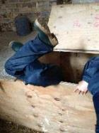
6.30pm – The Handlebards’ ‘Twelfth Night’ – bicycle powered Shakespeare as you have never seen it before! (Bring your own seating/rug)
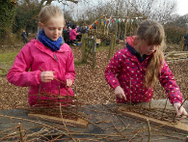
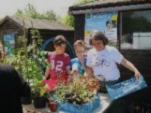
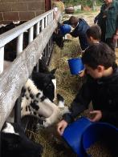

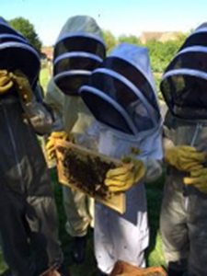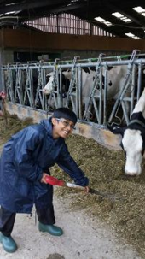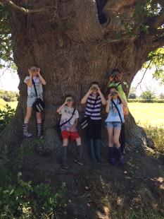

SPONSORSHIP OPTIONS

Every sponsor will be acknowledged on all Farms for City Children social media platforms in connection to the celebrations, tickets to the entire day with all the other VIPs, and acknowledgement in the souvenir Programme

STANDARD PACKAGES –

£100 – 2 tickets for the day including the evening Shakespeare performance
£200 – 4 tickets, a parking space in the proposed parking with your own plaque
£400 – 6 tickets, 2 parking spaces in the proposed parking with your own plaques

PREMIUM PACKAGES -
£500 – 8 tickets, 2 parking spaces with your own plaques, 2 banners placed along the drive, a banner in the reception area
£1000 – 20 tickets, 5 parking spaces with your own plaques, 4 banners placed along the drive, a banner in the reception area and a banner in the orchard (venue for Twelfth Night), special corporate membership of Friends of Wick Court for a year and preferential rates for use of Wick Court for your own event (out of term time only)

We are always happy to create a bespoke option to suit your needs

If you would like to know more, including visiting the farm and its beautiful Elizabethan house to see the magnificent work being done, please contact: Heather Tarplee (Farm School Manager) on 01452 741023 or email heather@farmsforcitychildren.org

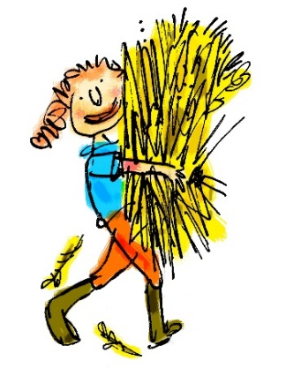
We hope you will join us to celebrate!
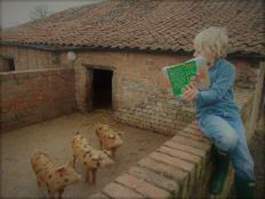

Farms For City Children - Wick Court
Overton Lane, Arlingham, Gloucester, Gloucestershire, GL2 7JJ
www.farmsforcitychildren.org
Registered Charity number: 325120

