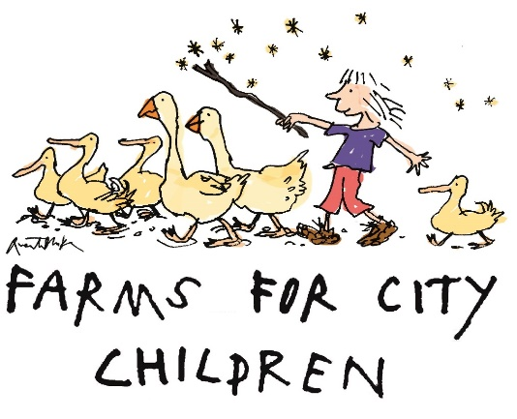

FFCC Equal Opportunity Monitoring Information

Personal information including gender, ethnicity and age is collected by FFCC for monitoring purposes only and will not be used in any decisions affecting you.
This page is an optional part of our recruitment process that will help us further analyse your response based on the demographic data you provide us with. The responses that you give will assist us greatly in our commitment to diversity and will be kept strictly confidential.

- Gender: Which of the following best describes your gender?
☐Male | ☐ Female | ☐ Prefer not to say | ☐ Prefer to self-describe
Option to self-describe

- Sexual orientation: which of the following best describes your sexual orientation?
☐Bi | ☐Gay or Lesbian | ☐Heterosexual/straight | ☐Prefer not to say | Prefer to self-describe
Option to self-describe

- Gender identity: do you identify as trans?
☐Yes | ☐No | ☐Prefer not to say | ☐Prefer your own term
Option to self-describe

- Disability: do you consider yourself to be disabled?
☐Yes | ☐No | ☐Prefer not to say
Under the Disability Discrimination Act, a disability is defined as a physical or mental impairment that has a substantial and long-term adverse impact on the ability to carry out normal day to day activities.
- Ethnicity: what is your ethnic group?
☐Arab | ☐Asian or Asian British: Indian | ☐Asian or Asian British: Pakistani
☐Asian or Asian British: Bangladeshi | ☐Asian or Asian British: Chinese | ☐Asian or Asian British: Other
☐Black or Black British: African | ☐Black or Black British: Caribbean | ☐Black or Black British: Other
☐Mixed: White and Black Caribbean | ☐Mixed: White and Black African | ☐Mixed: White and Asian
☐Mixed: Other | ☐White: British | ☐White: Irish
☐White: Other | ☐Prefer not to say
☐If you have any other ethnic group or you prefer your own definition, please specify

- Religion and belief: what is your religion?
☐Buddhist | ☐Christian
☐Hindu | ☐Jewish
☐Muslim | ☐Non-religious
☐Sikh | ☐Other
☐Prefer not to say
☐Prefer to self-describe:

- Age:
☐16-24 | ☐25-34 | ☐35-44 | ☐45-54 | ☐55-64 | ☐65+ | ☐Prefer not to say

