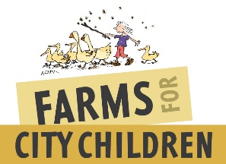
Volunteer Application Form

Volunteer Role
Role Location
How did you find out about this opportunity?

Your details
Name
Address
Telephone
Email

About you
Please tell us about your interests, skills and experience in relation to the role you are applying for.

Why do you want to volunteer for Farms for City Children?

Emergency contact details
Please provide the details of someone we can contact in the unlikely event of accident or illness while you are volunteering; these details will not be passed on to any third party and will be kept securely with your information.

Name
Relationship to you
Telephone

Additional information
Please indicate yes or no in the box to the following questions.

Are you entitled to volunteer within the UK?  If you are from the UK, you are free to volunteer, so are the majority of citizens within the European Union (EU). For those outside the EU please check that your visa allows you to volunteer. If you are uncertain we recommend you contact the UK Borders and Immigration Agency for clarity. | Y/N
Do you have any unspent criminal convictions or is there any action pending against you? Having a conviction will not necessarily stop you from volunteering. Please provide brief details so we can discuss this with you. | Y/N
Farms for City Children welcomes volunteers with a wide range of skills, abilities and needs and we want to promote a welcoming and inclusive environment for all. To help us consider any appropriate adjustments required and to better support you, please give us some brief details below of any disabilities or health concerns we need to know about, so we can discuss this with you.

Please leave blank if this does not apply to you.

Reference
Please provide details of a referee you are happy for us to contact to provide a reference for you.

Name
Relationship to you
Email address

Data Protection
The information that you have provided is required to register your interest in volunteering with Farms for City Children. It will be held securely on the Farms for City Children volunteer database and in line with Data Protection Legislation.

We would love to keep in touch with news about Farms for City Children.
Please tick below to tell us how you want to hear from us:

By post | Yes | No
By email | Yes | No

Next steps
Please sign below to confirm the information you have provided is true:

Signed
Date

Please send your completed application form to: recruitment@farmsforcitychildren.org

We will be in touch to talk to you about the next steps.

